**March on Washington Math Lesson**

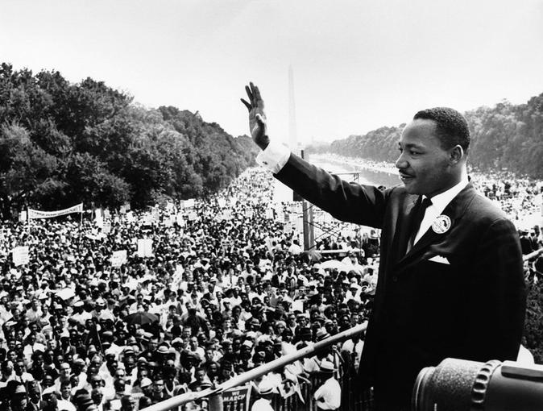

*During the March on Washington, 250,000 people came to march and listen to speakers like Martin Luther King Jr. You are going to make a representative map of all the people who were there.*

1. *Since you will not have 250,000 sticker dots, figure out how many you will need to represent the 250,000 people who attended the March.*
2. *Arrange them on the map so you can experience how many people were there.*
3. *Make sure to make a key to show how many people equal one (1) sticker.*
4. *You may also decide to represent the percentage of white and black attendees with different color pushpins (see pie chart below for help.)*
5. *80% were black and 20% were white.*
6. *The areas below equal 20% each. Shade in the correct number of sections to represent the percentage of black and white people who attended the March.*

***Percentage of Black and White People at the March on Washington:***

